The Life Sciences Instruments at ALBA

Current Instruments

MISTRAL: soft X-ray tomography and spectromicroscopy
MISTRAL aims at imaging the near-native structure of cells at a resolution of ~30nm in a volume of 16×16×10 µm³ by means cryo soft X-ray tomography (cryo-SXT). The observed frozen, hydrated cells do not need to be sliced or chemically modified, preserving the native structure. The region of interest is selected using an on-line visible light epifluorescence microscope for correlative, low-resolution 2D imaging.
MISTRAL is also able to perform cryo-spectromicroscopy experiments to locate oligoelements or heavy atoms from introduced nanoparticles or compounds in the cell ultrastructure. Interestingly, this chemical characterization can be correlated with the morphological information delivered by cryo-tomography on the same sample.
The information obtained using MISTRAL can be combined with data from cryo-electron tomography, cryo-FIB, nano X-ray fluorescence or infrared spectro-microscopy experiments. In addition, our recently developed cryo-3DSIM visible microscope provides 3D images at 100nm-resolution and allows to correlate the laboratory imaging methods with the unique imaging techniques at MISTRAL.
Most of the experiments are dedicated to health (pathogenic infections, cancer and diseases), biomineralization, nanoparticles internalization, drug delivery or characterization of particular organelles or structures inside the cell.
The necessary steps for the experiment, namely in situ cell culture, cell vitrification, sample screening and tutorials on data processing are provided by the scientific beamline staff.

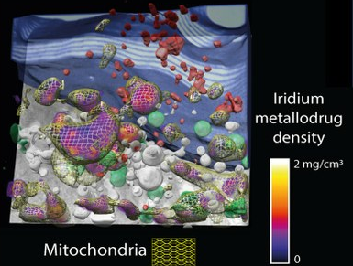 | 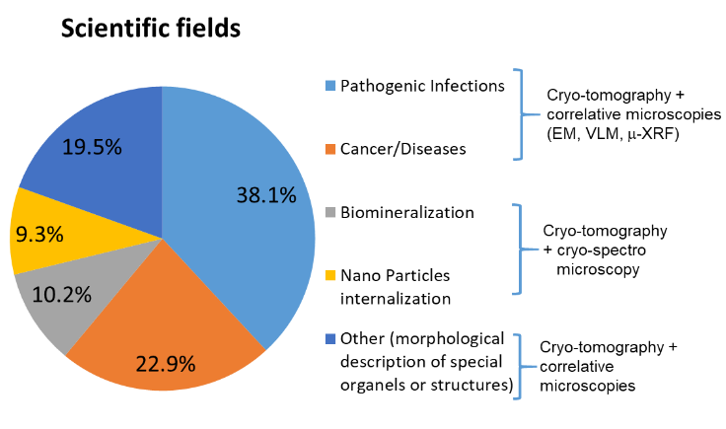
Figure 1. (left) Localization of a metallodrug within the cellular ultrastructure. (right) Scientific fields of the experiments at MISTRAL.

MIRAS: infrared micro-spectroscopy
MIRAS beamline is able to map non-destructively the state of bio macromolecules in their natural environment at a spatial resolution of ∼3µm by means of infrared micro-spectroscopy. Output data is delivered either as spectral analysis (spectroscopy mode) or as images (microscopy mode). The beamline includes user friendly control system and provides a service of remote access of users to data analysis software.
The applications cover a wide range of research fields in life sciences including cancer, Alzheimer and other neurodegenerative diseases, cells infection, protein aggregation, lipids peroxidation and biomarkers in cells/tissues. Samples may consist in single cells layers or tissues. Sample preparation tools and tissue cryo-sectioning are available, so that data can be correlated with cryo-SXT (MISTRAL), visible microscopy (including super-resolution techniques), nano-Xray Fluorescence, nano-Xray spectroscopy and micro-computed tomography (FAXTOR, when in operation).
MIRAS is particularly interesting for pharma and cosmetic companies to verify the diffusion, efficacy and safety of active ingredients by analyzing the biochemical composition of the cells and tissues upon treatment.

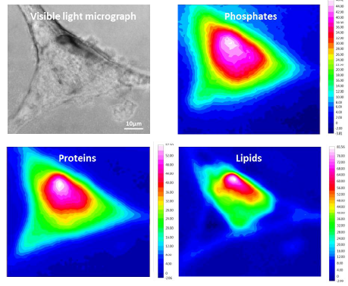 | 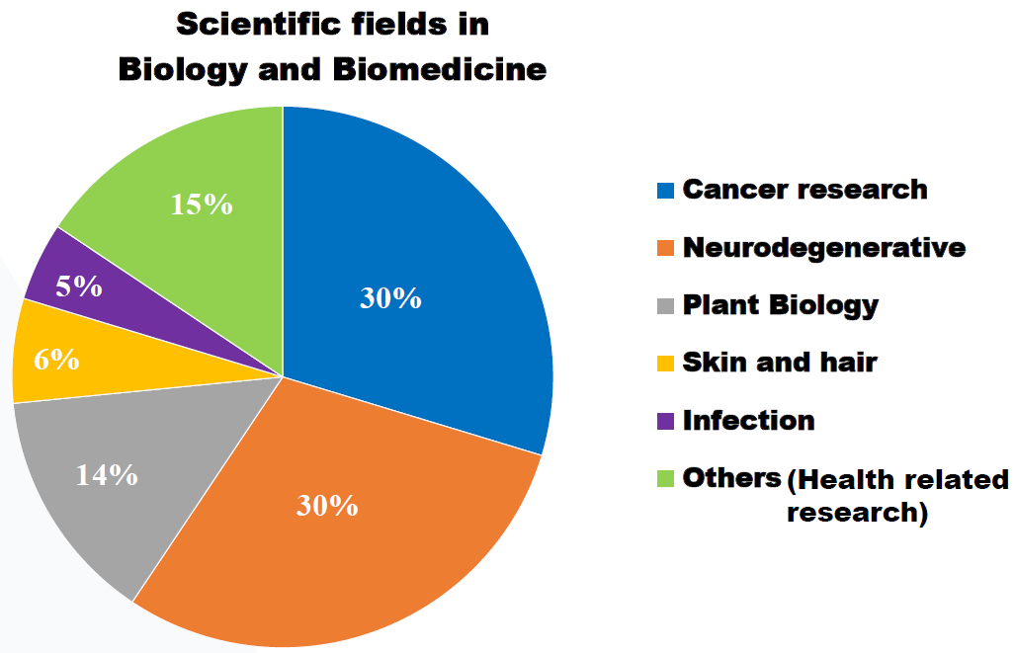
Figure 2. (left) Localization of phosphates, proteins and lipids in astrocyte cells affected by amyotrophic lateral sclerosis. (right) Scientific fields of the experiments at MIRAS.

XALOC: macromolecular crystallography
XALOC provides a tool to determine macromolecular 3D structures at atomic resolution by means of macromolecular crystallography (MX). The technique is suitable to study proteins, oligonucleotides and protein-protein, DNA-protein or ligand-protein complexes. In the end, MX reveals the molecular machinery of life at atomic level.
Macromolecular crystallography relies in the availability of the studied macromolecules in a crystal form. The obtained 3D structures from these crystal benefit all and every topic on health, environment and other societally-relevant challenges that require the understanding the interaction of biological components at the most intimate level: pathogen infections, antibiotic resistance, crop growth and resistance to climate change, cancer, diseases, drug delivery and distribution, bionanomaterials, time-resolved enzymology, etc. The most common use of the technique has been the structural determination of drug-target interactions, ultimately improving the design of drugs with higher activity and selectivity and accelerating the drug discovery process.
MX experiments can be operated remotely. ALBA offers a crystallization platform to accelerate the production of macromolecular crystals to academic and proprietary research.

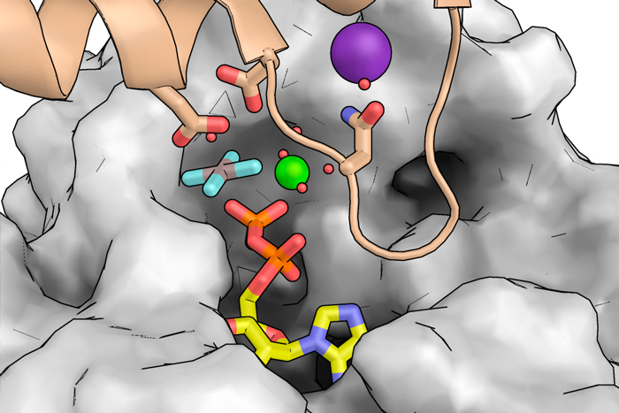 | 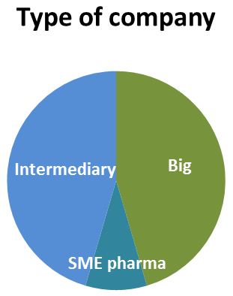
Figure 3. (left) The observed conformational changes of FtsZ enzyme when binding to GTP nucleotide (in red and yellow) are essential for the cell division of antibiotic-resistant bacteria. Once characterized the enzyme can be used as a therapeutical target (Ruiz et al. PLoS Biology, 2022). (right) Size of the pharma companies using ALBA synchrotron.

Near-future instruments in construction

XAIRA: advanced micro-macromolecular crystallography
New methods are developing in macromolecular crystallography to cope with increasing difficulty of the projects and tackle unexplored challenging biological processes. These new methods include collecting data from tiny, micron-sized crystals, data from non-cryogenically preserved samples and ultrafast time-resolved experiments to study conformational changes of proteins. In response to these new challenges ALBA is constructing a specialized MX beamline able to cope with the most demanding experiments.
The beamline is foreseen to start operation by end 2023

FAXTOR: Micro-computed tomography
FaXToR will allow 3D imaging of tissues and materials as large as several cm at a spatial resolution between 1 and 10 µm. Static and time-resolved experiments using standard absorption-contrast methods or enhanced phase-contrast imaging will be possible. Some examples of applications are the morphological dynamics in human cartilage plugs under external loads; the morphological changes in pathologic liver biopsies; the multi-modal visualization of the effects of microbeam radiation therapy or the 3D distribution of motor neurons in spinal cords.
The morphological information at the micron scale in large volumes provided by µCT is to be correlated with other techniques already available at ALBA like infrared micro-spectroscopy (at MIRAS) and cryo-SXT (at MISTRAL).
The beamline is expected to start operation by 2024.

Future instruments – funding in negotiation

CALIMA: Small angle X-ray scattering on bio-macromolecules
CALIMA aims at elucidating the shape and ultimately the function of macromolecules in solution at a resolution of 5-10 angstroms using Small Angle X-ray Scatering on biomolecules (BioSAXS). Sample preparation is generally easy and only requires a high degree of monodispersity. The techniques is also able to find the structure of soft materials such as fibers or polymers.
BioSAXS is a key player in the “era of structural dynamics” for it can reveal the structural evolution during oligomerization, assembly or folding of macromolecules and macromolecular complexes, as well as their response to physical and chemical stimuli in real time. When microfocused, the samples can be mapped so that structural changes at a molecular level can be spatially-resolved at a resolution of a few µm.
BioSAXS can also be used in drug discovery by studying the whole cycle of the drug-target dynamic interaction. These studies relate the observed changes with a particular function or phase of the interactions and can reveal the loss of efficacy of newly designed drugs. Also, the information provided by BioSAXS can be combined with macromolecular crystallography and electron microscopies for a multi-scale approach to molecular studies.

Beyond the synchrotron

Single particle cryo-EM
Single particle analysis of cryo-electron microscopy (cryoEM-SPA) has raised as a powerful technique to find the molecular structure of large assemblies and targets that are difficult to produce. For projects working at multiple length-scales, cryoEM is very appropriate as it can act as bridging technique between structural studies at macromolecular level (MX, bioSAXS, computational modelling) and those focused at cellular level (electron and X-ray tomography).
A state-of-the-art Glacios 200kV microscope has been installed at ALBA premises, fully equipped with a cold field emission electron gun and a top-quality detector. A vitrobot plunge-freezer and a sample autoloader are available for handy sample preparation and loading. The software system, together with the assistance of the scientist in charge, allow the users to assess the data quality and make decisions during data acquisition. Experiments can be operated remotely.
The instrument is currently in commissioning and is expected to receive first users by end 2022.

Figure 4. From cryo-EM-SPA images (left) to high resolution maps (middle) and final models at near atomic resolution (right).

